**Procedure to run the test script**

**Pre-requisites:**

1. Python 3.9.
2. Google Chrome browser (latest).

**Python 3.9 link**:

<https://www.python.org/ftp/python/3.9.11/python-3.9.11-amd64.exe>

**Python Installation link:**

<https://docs.python.org/3.9/using/windows.html#installation-steps>

During installation click the checkbox "Add Python 3.9 to PATH"

Follow the below steps post installing Python and Google Chrome browser

1. Unzip the shared archive file and double-click on the unzipped folder.

2. Enter ‘cmd’ in address bar and press enter.

3. Command Prompt will open on the screen.

4. Type ‘env_setup.bat’ and press enter.

5. Python environment set up is initiated.

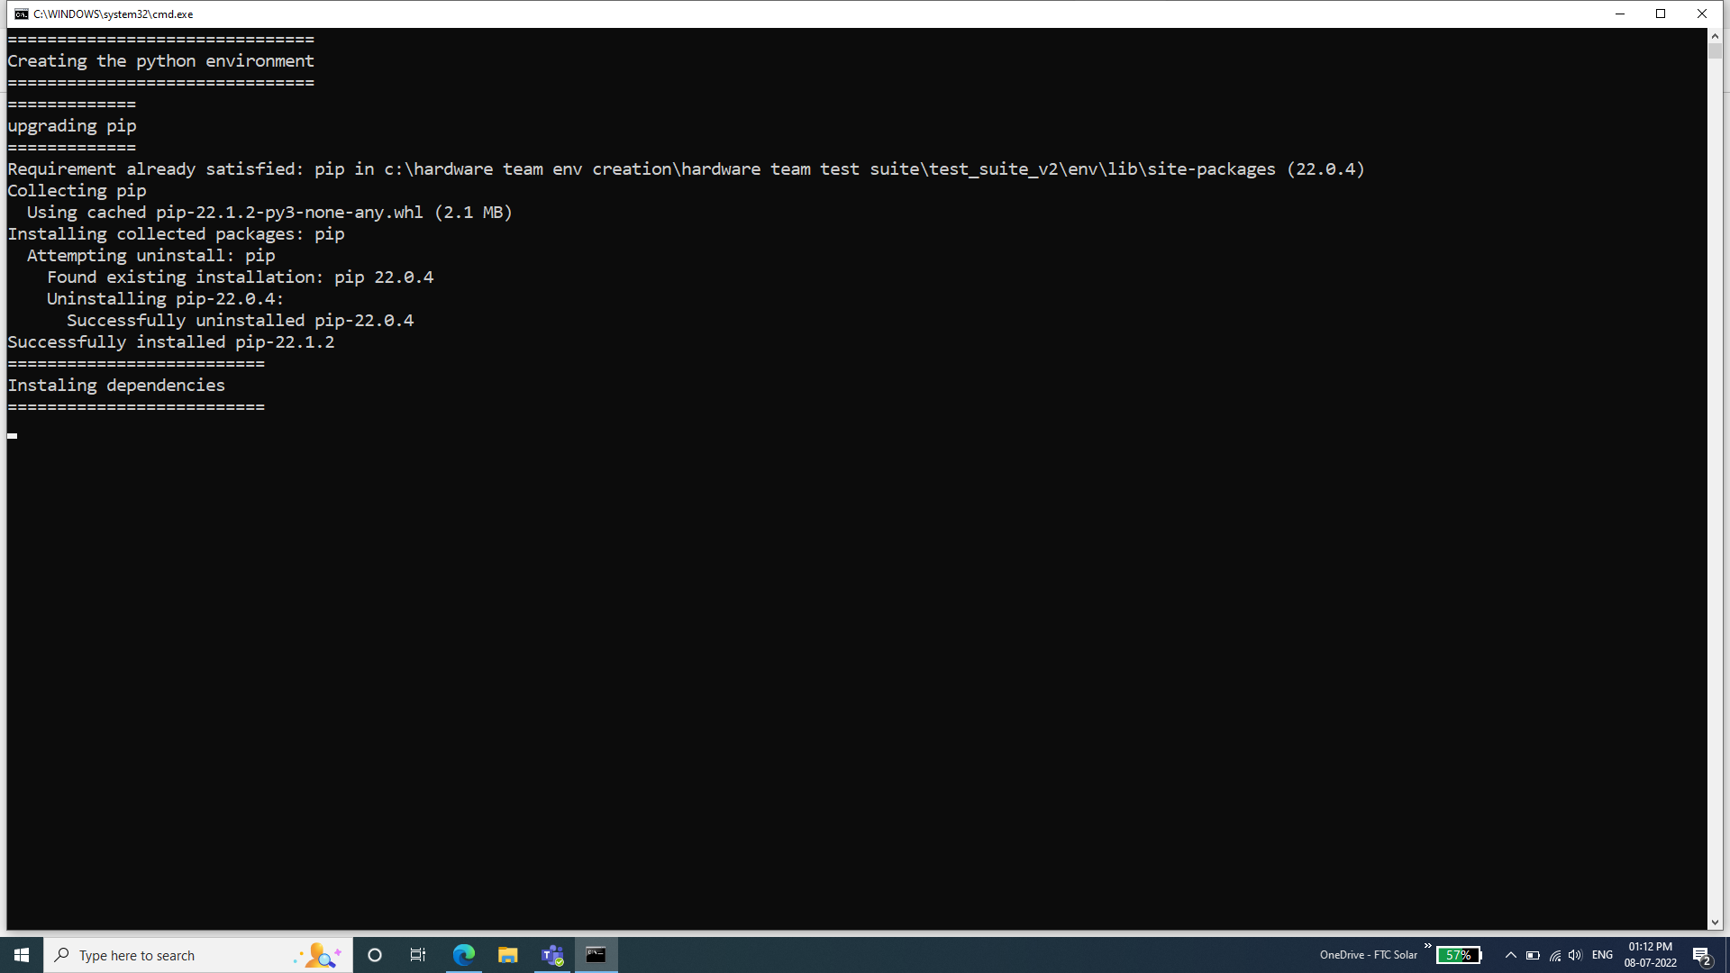

6. Below is seen once the set-up is completed the

7. Run the test suite by typing ‘python main_script.py’ and press enter.

8. While the suite is running the browser will automatically open. The terminal also shows the test being run. If the test is running on windows machine then please ignore the warnings. Wait for the browser to close which indicates the test suite execution is completed.

9. After executing all the test scripts a report (Report_serial No.txt) will be found in same directory where archive file is extracted.

Note:

1. Before running the test suite, system should connected to Zone Controller’s hotspot.
2. Row Controller should be configured with the panID same as in Zone Controller.
3. Internet Connection is must for the following:
4. Testing NTP sync from UI.
5. Environment setting (env_setup.bat)
6. Sensors should be connected to ZC before running the suite.

**List of Test cases in the suite**

Test Case 1:Login using Zone Controller hotspot(192.168.4.1).  
Test Case 2: Checking the status of Disk/RAM used in the ZC.  
Test Case 3: Checking CPU Temperature  
Test Case 4: Verifying Bluetooth is Enabled/Disabled  
Test Case 5: Checking SD Card is available in ZC(Read/write is not being checked)  
Test Case 6: Testing Login (Admin) in UI with dynamic IP.  
Test Case 7: Checking UI navigation across screens

Test Case 8: Checking for Sensor driver's installed status

Test Case 9: Checking for Hardware/ Software Versions

Test Case 10: Checking for Sensor reading data  
Test Case 11: Checking Zigbee Pan ID’s and adding Row Controllers

Test Case 12: Checking for NTP Sync  
Test Case 13 : Checking for board temperature in the metrics section